EXPERIMENT- 05
Perform Moving of an Image from One Place to Another
Aim
To write a Python code to read an image and perform image translation for moving the image from one position to another using OpenCV image transformation methods.
Input Image
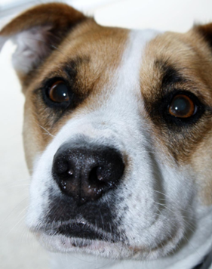
Code
import cv2
import numpy as np
from google.colab.patches import cv2_imshow
from google.colab import files
uploaded=files.upload()
image_path=list(uploaded.keys())[0]
image=cv2.imread(image_path)
if image is None:
print("Error: Image not found")
else:
rows,cols=image.shape[:2]
matrix=np.float32([[1,0,50],[0,1,30]])
moved_image=cv2.warpAffine(image,matrix,(cols,rows))
print("Original Image")
cv2_imshow(image)
print("Moved Image")
cv2_imshow(moved_image)
Output Image
Moved Image
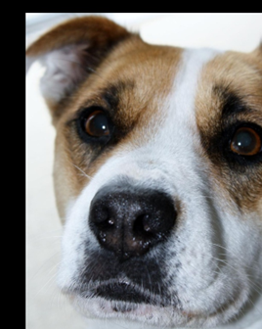
Result
Thus, the image was successfully moved from one position to another using OpenCV.

